GENERIC RISK ASSESSMENT | Food Preparation - primary |  |  | 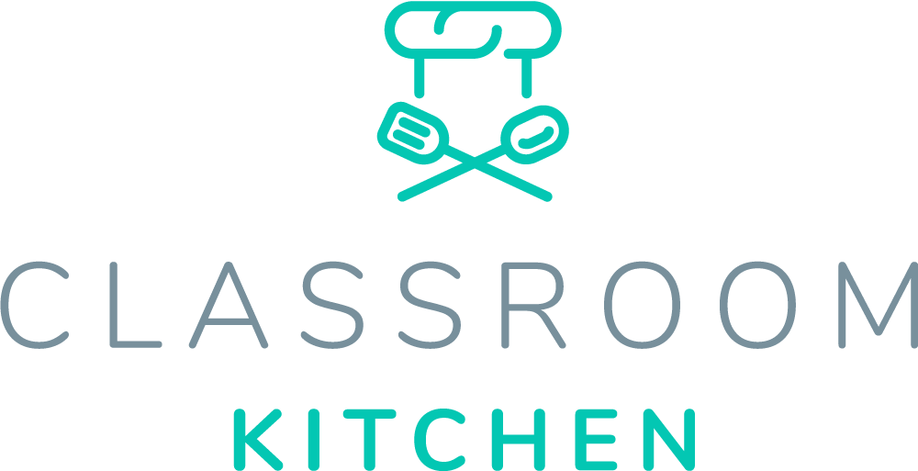
Establishment: | Generic Assessment by:  Innovative Education Ltd  Reviewed and Edited by: | Date:
Review Date: | Approved by: | Date:

DISCLAIMER: This Risk Assessment is a template for use by Classroom Kitchen Online Users (a service provided by Innovative Education Ltd). The risk assessment covers possible risks and hazards of cooking (food preparation) in schools. Innovative Education Ltd takes no responsibility for incidents that occur within a school using this Risk Assessment. The responsibility lies with the user. As a company, Innovative Education Ltd cannot assess every individual school and its possible risks and hazards. This template has been created to assist the school (user) in developing their own, personalised risk assessment to their school’s needs, hazards and risks.

User: Please read the suggestions thoroughly and edit accordingly. Ensure the completed Risk Assessment is read and understood by all parties who will be responsible for the delivery of Cooking (Food Preparation) in your school. It should be signed and approved by a senior member of the school and reviewed annually (it may be of interest to review earlier if conditions or the setting change).

Hazard / Risk | Who is at Risk? | Normal Control Measures  (Brief description and/or reference to source of information). | Additional Control Measures  (to take account of local/individual circumstances). | Risk Rating  H/M/L
Hot surfaces liquids / Burns, scalds | Staff, pupils,  volunteer helpers | - Lifting lids off pans & kettles, moving hot tins, dishes and water to be restricted to adults only.  - Adequate supervision and safe working procedures in place.  - Position pan handles not to overhang the edge of the cooker.  - Ensure adequate space is available around the ovens at all times when handling hot items.  - Keep electrical equipment and hot liquids away from areas where pupils are working (consider layout of space to ensure safe working).  - Position Cookers/Hobs/Kettles/Other Electrical Equipment away from fire exits and exits/access points/common walkways. |  | L
Sharp equipment /  Cuts | Staff, pupils,  volunteer helpers | - Controlled storage and use of knives and other sharp equipment.  - Pupils taught correct techniques for use of knives and other equipment and use under adult supervision.  - Knives are kept sharp as blunt knives can cause serious injuries.  - Wash separately do not leave in sink.  - Limit number of children using sharp equipment at one time.  - Ensure all children are aware of others using sharp equipment and give adequate space. |  | L
Slippery floors / Slips and trips | Staff, pupils,  volunteer helpers | - No obstacles in walkways and regular cleaning of floors.  - All children standing in cooking areas with chairs under tables. In circumstances where children cannot stand, a safe area will be identified.  - Prompt maintenance of defects.  - Spillages should be dealt with immediately.  - Paper towels to be used on small areas of water-based contamination.  - Ensure good housekeeping and that any spills / food debris are cleared up immediately.  - Limit movement around the cooking space, ensuring movement is only granted when safe to do so. |  | L
Use of cookers (Electric / gas)  Electric shock  Fire, explosion | Staff, pupils,  volunteer helpers | - Electrical equipment is subject to regular safety inspection and test ('PAT testing).  - Children must be supervised at all times whilst cookers and hobs are in use.  - Ovens for food preparation not to be used for other purposes e.g. heating plastics.  - Fire blanket/Fire Safety equipment kept in the area and staff should know how to use it.  - Cookers and ovens should be sited away from flammable materials, doorways, passageways and fire escape routes.  - There should be no wall displays, pin boards etc in the close vicinity.  - Use cookers in spaces away from the pupils (consider the arrangement of the classroom/cooking space).  - Educate the children on the need for safety around the equipment. |  | L
Food poisoning  Poor standards of hygiene  Incorrect storage of food) | Staff, pupils,  volunteer helpers | Personal hygiene  - Pupils taught the need for personal hygiene. Staff and pupils to wash hands before handling food and after visits to the toilet.  - Ensure that warm water, soap and towels (disposable) are available.  - Cuts etc. are covered with waterproof adhesive dressings.  - Tie back long hair.  - Aprons hygienically maintained  Storage  - Avoid the use of foods that require refrigeration if safe temperatures cannot be maintained  - Only small quantities of food should be stored, and correct stock rotation should be ensured.  - “Use by” and “best before” dates should be checked.  - Food stored in suitable containers. (covered / protected from contamination)  - Foods appropriately covered / wrapped and stored prior to taking home. Pupils provided with instruction on safe storage / consumption/cooking lengths and temperatures etc. |  | L  L
 |  | Food handling  - High risk / raw foods kept apart at all times  - Separate chopping boards and utensils used for raw and cooked foods.  - Equipment, including cutlery, should be stored in secure, clean conditions and used only for food preparation.  Cleaning  - Work surfaces cleaned with a multi-purpose cleaner and then disinfected prior to any food preparation.  - Where a classroom table has to be used for food preparation it should be covered with a clean plastic sheet  - Equipment, including cutlery, should be stored in secure, clean conditions and used only for food preparation.  - Adequate rubbish bins for waste food and they must be emptied daily. |  | L  L
Pupils with food allergies/dietary requirements  Inadvertent contact  Staff not aware of pupil’s allergies | Staff, pupils,  volunteer helpers | - All staff/volunteers are made aware of pupils who are sensitive to foods and food additives.  - Staff should be aware of ingredients/food additives present in foodstuffs.  - All foodstuffs checked by staff members prior to lesson to ensure these are safe to use.  - Frequent contact with parents/guardians of pupils to ensure awareness of new allergies and dietary requirements.  - Any doubt, do not taste the food at the end of the session and ensure all pupils thoroughly wash hands. |  | L
Covid 19 and the spread of other diseases/bacterium. | Staff, pupils, volunteer helpers | - Social Distancing to be observed when required and to the school’s rules.  - Hand washing should take place regularly (prior to the session/after the session and during where necessary).  - Pupils should keep to using individual equipment.  - Wash equipment where necessary and between uses.  - Wash equipment at a high temperature with bacteria killing soaps.  - Equipment should not be used between bubbles within a 72-hour period of one another.  - Food tasting should only be from foods prepared and touched by the individual. Where possible, children should take home foods.  - Aprons and other protective equipment should be worn and disposed of after uses. |  | L

REVIEWS:

GENERIC ASSESSMENT (PRIOR TO USER EDITS) REVIEWED BY:  James Deveney (Director of Innovative Education Ltd) | COMMENTS:
GENERIC ASSESSMENT (EDITED AND ASSESSED) REVIEWED BY: | COMMENTS:

Classroom Kitchen is a service provided by Innovative Education Ltd (2018)

